ROBERT & DAVID LETTER | Government reopening
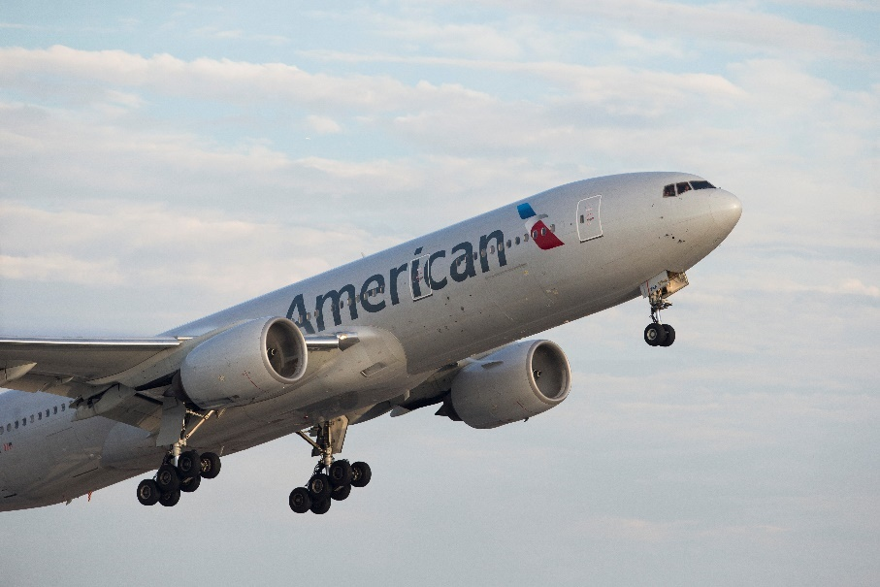
A note from Robert and David: Thank you for your hard work
In a message to team members, CEO Robert Isom and COO David Seymour give thanks for looking after our customers during the government shutdown.
Fellow team members,
Our government has been shut down for the past six weeks, which has made for an incredibly challenging time for our airline and the industry as a whole. Most importantly, it was extremely disruptive to our customers. In the past week, we saw a crescendo effect as air traffic control staffing shortages led to massive and unpredictable amounts of delays and cancellations across the industry — and that was on top of a series of FAA-mandated schedule reductions. While we both have been in this industry for a long time, only a few other events come to mind when we think about this level of disruption.
Thankfully, that chapter is now over. The government is reopened and the shutdown is behind us. Our message to you is simple and yet cannot be overstated: Thank you. Thank you for the long hours, the hard work and the round-the-clock care you’ve shown to our customers and each other. Times like these are never easy for anyone, and the care and compassion we’ve shown for people on life’s journey in the past month — during incredibly challenging times for our operation — truly makes us proud.
Relentless support of our customers
Throughout this long week of disruption, we took great care of our customers, publishing a travel alert that allowed changes to their travel plans across our network, regardless of impact. We methodically reduced our schedule in a way that minimized impact on customers and crew members and maximized our ability to reaccommodate customers. We were transparent, communicative and supportive, and our customers noticed. Three of the four top net promoter score (NPS) days of the year so far were during this period of disruption, proving how we stepped up to the plate — proving no one manages through and recovers from a disruptive event quite like American.
The days ahead
Reopening the government is a critical step forward, and we’re grateful to our leaders in Washington, D.C., for coming together to make that happen. And of course, we must thank federal aviation workers — including air traffic controllers and TSA officers — for coming to work without a paycheck and maintaining the safety and security of our nation’s aviation system. Next is getting air traffic controllers and other federal aviation workers paid, and then making sure the FAA is comfortable with staffing at its facilities. We’ll always follow the FAA’s lead as it ensures the safety of the national airspace system. When we get the green light, know this: American is ready.
In the meantime, air traffic control staffing has begun to stabilize over the last day or so, and we’ve already seen that materialize in our operation. What that means for our customers and team is fewer day-of delays and close-in cancellations. It means predictability. Still, it may take a few days for fully normal controller operations to resume, and we may need to continue to reduce schedules to comply with the FAA‘s emergency order requirements. But we have seen promising signs and are confident that because of our strategic planning and work to minimize customer impacts throughout this period, we will recover quickly and deliver a strong Thanksgiving operation. The millions of customers who chose American to reconnect them with friends and families and get them to the table deserve the certainty.
And this year, there is a lot to be thankful for.
Thank you again for your hard work. Be safe.

Robert Isom David Seymour
Chief Executive Officer Chief Operating Officer

